Group Show at Contemporary Istanbul

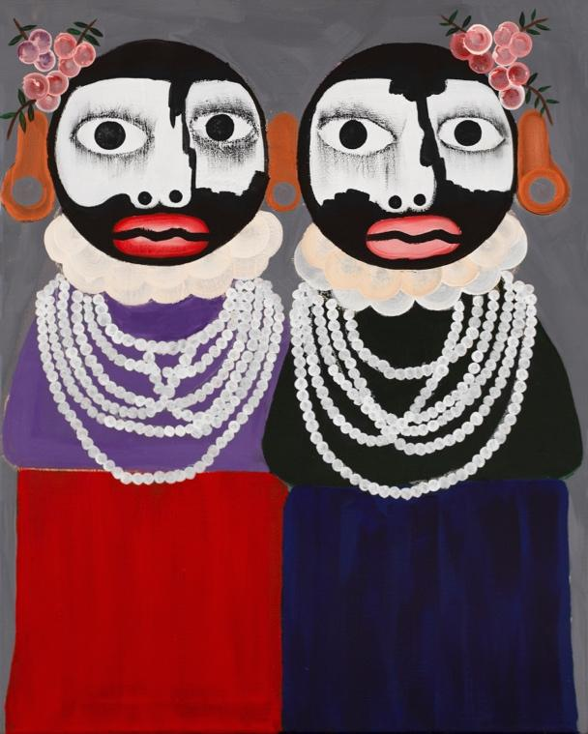
Kojo Marfo, Untitled, 2022, Acrylic on canvas, 24 3/8 x 30 1/4 in, 62 x 77 cm

JD Malat Gallery is pleased to present its group exhibition for the 17th edition of Contemporary Istanbul, bringing together highly expressive works by the following six artists: London-based Ghanaian artist Kojo Marfo, Spanish artist Luis Olaso, Turkish artist Zümrütoglu, Colombian artist Santiago Parra, Turkish sculptor Hande Şekerciler and British artist Georgia Dymock.

Through its diverse international selection of contemporary artists for the art fair, JD Malat Gallery aims to contribute to the multicultural dialogue within the creative scene of Contemporary Istanbul 2022 and highlight the gallery’s innovative and uniting role in the world of contemporary art. By bringing together the works of artists with diverse cultural backgrounds, age groups and academic bases, JD Malat Gallery seeks to offer multiple viewpoints on the contemporary human condition and the notion of identity.

The booth features two recent paintings by Colombian artist Santiago Parra, known for his large, abstract and highly expressive monochrome paintings. The artist explores the expressive possibilities of the quintessential abstract form. Guided by his creative instinct, Parra works in a single brush stroke technique, combining the aesthetics of Japanese calligraphy with the concept of ‘Automatism’ – a technique developed by Surrealists in the 20th century. In his continuous search for autonomous expression and materialisation of the unconscious mind, Parra remains faithful to his medium – black acrylic on raw canvas, this time introducing a rough, almost rocky finish in his works- never seen in his practice before.

The notion of spontaneity is further explored in the work of Spanish artist Luis Olaso. Initially self-taught, Olaso works from complete improvisation. His artistic practice is divided into two parts: action and analysis. Deriving inspiration from Bilbao nature and his surroundings, Olaso scratches with oil pastel and applies impulsively constructed spots and drips of acrylic onto canvas which are altered later. Endowing his subject with a powerful emotional presence, Olaso departs from the traditional illustrative function of still life painting, making plants and objects the protagonists in his paintings. As such, the still-life compositions are not depictions of his environment but rather vibrant abstractions of his subconscious mind and lived experience.

The theme of the subconscious is also unveiled in the work of one of Turkey’s leading contemporary artists, Zümrütoglu. The artist explores authentic humanistic themes such as the fragility of human existence, revealing the narrative of his work through expressive brush strokes and the dynamism of colour. Strongly informed by his synaesthesia – the ability to see the sound and hear colour – Zümrütoglu’s work invites Istanbul’s audience to encounter humanity’s deep desire to search for harmony amongst chaos and reflect on anxieties regarding contemporary life.

The booth also features a painting by London-based Ghanaian artist Kojo Marfo. Sharing his observations of different people and cultures he has encountered throughout his life, Marfo articulates them in the language of figurative abstraction. Referring to himself as an Afro-Expressionist, the artist fuses elements from his Ghanaian background with Western Art references to critically engage with themes of identity and multiculturalism. With blocks of colour and strong shapes, Marfo encourages viewers to reflect on personal stories and the lives of others. His new painting for Contemporary Istanbul 2022 continues the ongoing conversation in his work and highlights the relevance of ideas embedded in Marfo’s practice at the international level.

Also on display is a new work by British artist Georgia Dymock. After captivating a global audience with her debut solo show in London and participation in artmonte-carlo 2022, Dymock has become recognised for her textured oil paintings of fluid tubular forms. Exploring the constant push-pull relationship between physical and virtual worlds, Dymock’s work reveals her re-imaginings of friends, family and self. Her process begins with manual sketches transposed into Photoshop and Illustrator digital software, which are then manipulated and translated back into the analogue world of paint on canvas. Inspired by her studies in Anthropology, Dymock’s paintings are hybrid entities, existing to comment on the paradox between digital technologies and oil paint.

The show also includes a unique sculpture by leading Turkish sculptor Hande Şekerciler. Renowned for her figurative forms, Şekerciler is influenced by artworks of the Hellenistic and Renaissance periods. The classical forms of her work are effectively combined with contemporary production methods. Merging digital technologies with traditional arts allows Şekerciler to utilise classical forms as a medium to discuss ultra-contemporary topics, such as identity, sexuality and self-acceptance. Stripping her figures of traditional gender identifiers such as body form, hair and genitalia, Şekerciler confronts the viewer with figures that inspire reflection on the multi-faceted nature of the ‘self’.

By bringing its group exhibition to the culturally diverse audience of Istanbul, JD Malat Gallery seeks to strengthen the dialogue between artists and viewers worldwide. Participation in Contemporary Istanbul 2022 reinforces our interest in situating the works of emerging and established contemporary artists within the broader cultural context, as well as encouraging the continuous discussion on universal issues through artworks, that stimulate imagination and allow the freedom of interpretation.

For images or further comment, please contact:
press@jdmalat.com

Location:
Booth A1-202
Halic Shipyards at the golden horn, Istanbul

